OOP Lab Assignment #1

Mohammad Yehya Hayati , 21K-3309 , BCS-2G

Table of Contents

**Task #1** 2

**Task #2** 3

**Task #3** 5

# **Task #1**

**• Write the program that will print your name and roll number**

**• Write the program of adding two numbers.**

**• The numbers must be given by user during run time.**

**Code:**

#include <iostream>

using namespace std;

int main()

{

//Part 1

cout<<"My name is Mohammad Yehya Hayati."<<endl<<"My roll number is 21K-3309."<<endl<<endl;

//Part 2

float a , b;

cout << "Please enter 2 numbers to add: ";

cin >> a >> b;

cout << "The sum is : " << a + b;

}

**Output:**

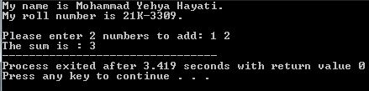

# **Task #2**

**• Write a program that can print first 10 numbers.**

**• Write a program that can print up to n.**

**• The number n must be given by user on run time.**

**• Write a program that can print from a to b.**

**• The number a and b must be given by user on run time.**

**Code:**

#include <iostream>

using namespace std;

int main()

{

//Part 1

int i;

for (i = 0 ; i < 10 ; i++)

{

cout << i << endl;

}

cout << endl;

//Part 2

int n;

cout << "Please enter n: ";

cin >> n;

for (i = 0 ; i <= n ; i++)

{

cout << i << endl;

}

cout << endl;

//Part 3

int a , b;

cout << "Please enter a: ";

cin >> a;

cout << "Please enter b: ";

cin >> b;

for (i = a ; i <= b ; i++)

{

cout << i << endl;

}

cout << endl;

}

**Output:**

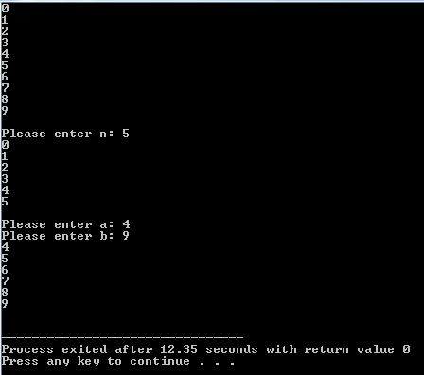

# **Task #3**

**• Write a program having following functionality using functions.**

**• Addition**

**• Subtraction**

**• Multiplication**

**• Division**

**• Hint. You must use different function for each functionality.**

**Code:**

#include <iostream>

using namespace std;

float Addition (float a , float b)

{

return a + b;

}

float Multiplication (float a , float b)

{

return a * b;

}

float Division (float a , float b)

{

return a / b;

}

float Subtraction (float a , float b)

{

return a - b;

}

int main()

{

float a , b;

cout << "Please enter two numbers: ";

cin >> a >> b;

cout << "a + b = " << Addition(a , b) << endl;

cout << "a - b = " << Subtraction(a , b) << endl;

cout << "a * b = " << Multiplication(a , b) << endl;

cout << "a / b = " << Division(a , b) << endl;

}

**Output:**

